***COAL Lab-1***

***Exercise 1.4***

**1**

1. **Type the program shown in the Figure above.**

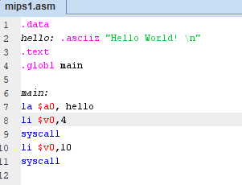

1. **Find out how to show and hide line numbers.**

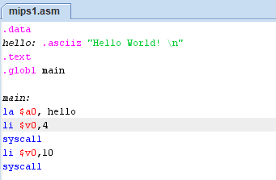

1. **Assemble and run the program.**

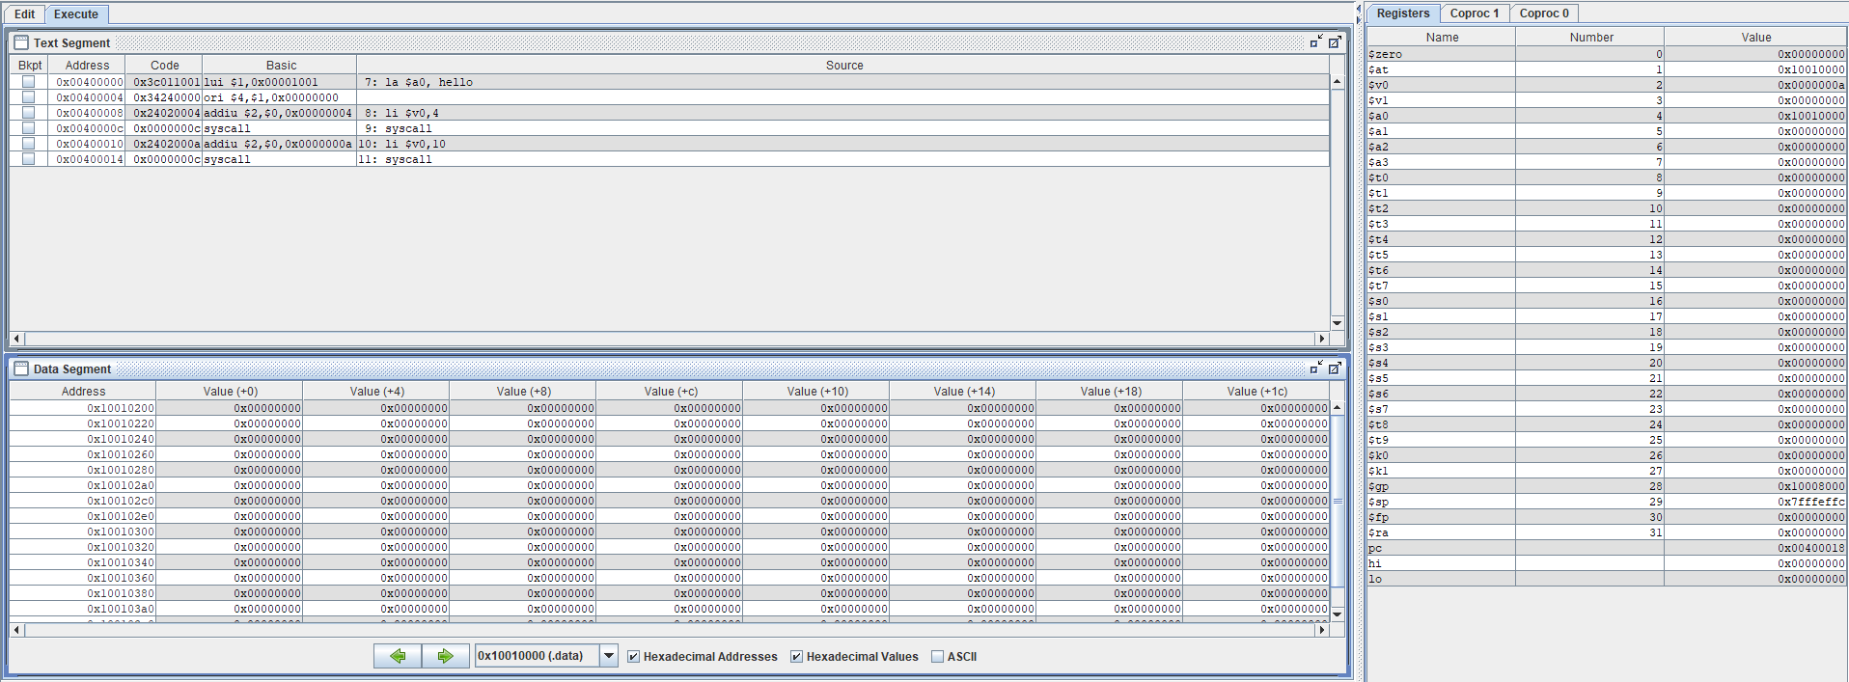

1. **What output does the program produce? and where does it appear?**

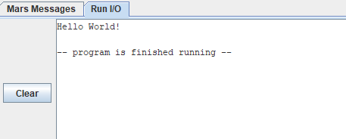

**2**

1. **Download and assemble the Fibonacci.asm program from the MARS website.**

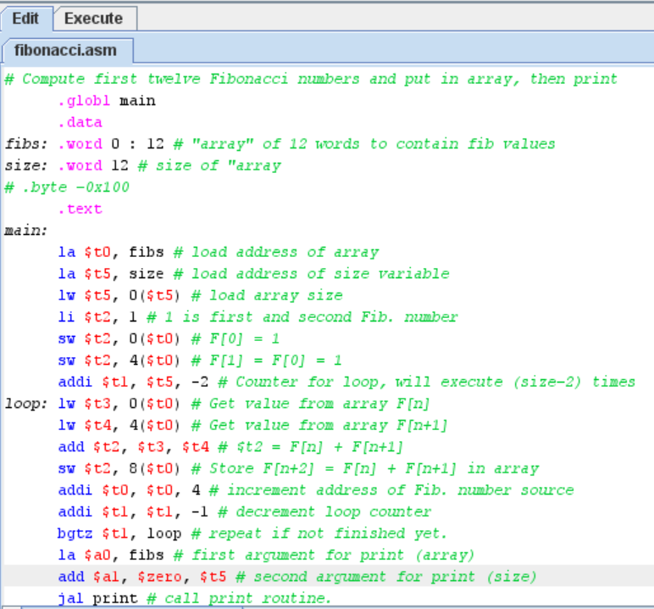

1. **Identify the locations and values of the initialized data.**

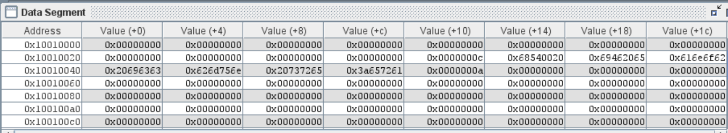

1. **Toggle the display format between decimal and hexadecimal.**

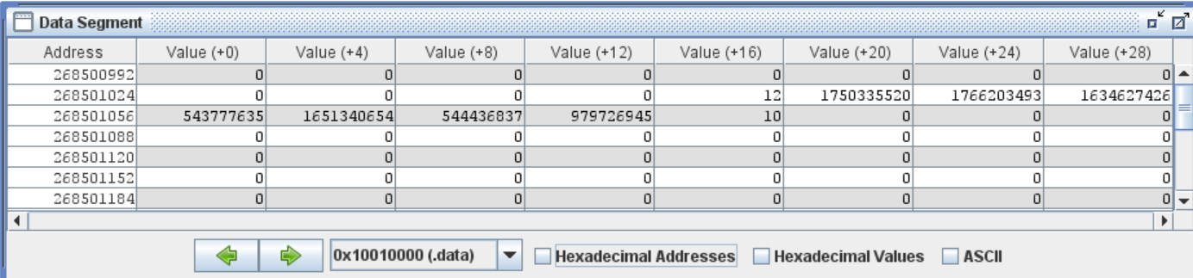

1. **Run the program at a speed of 3 instructions per second or less.**

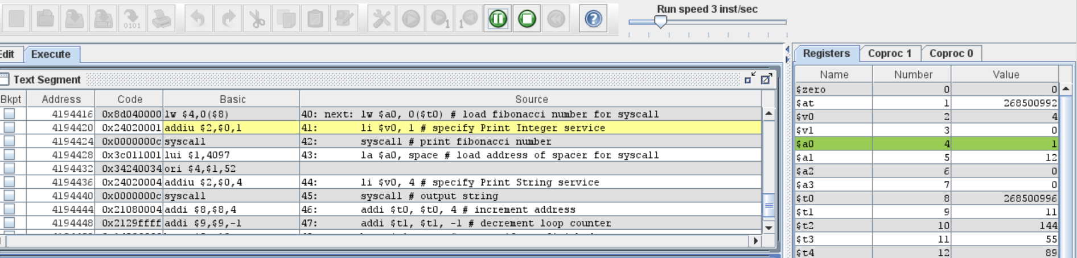

1. **Single step through the program and watch how register and memory values change**

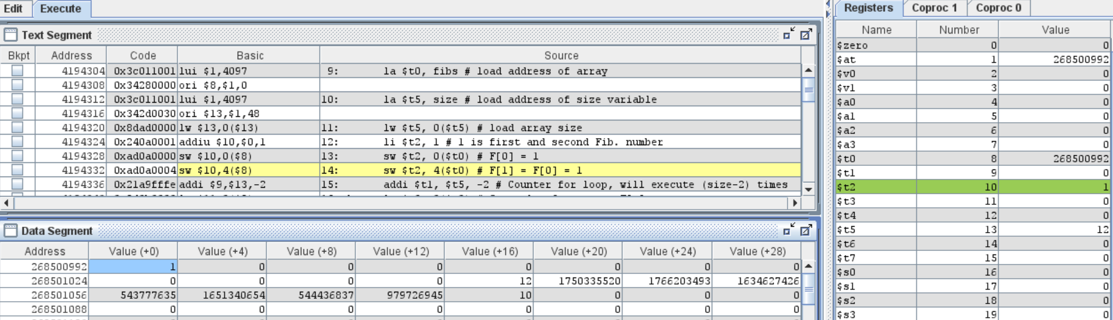

1. **Observe the output of the program in the *Run I/O* display window.**

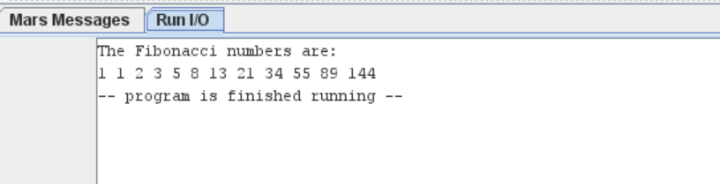

1. **Set a breakpoint at the first instruction that prints results. What is the address of this  instruction?**

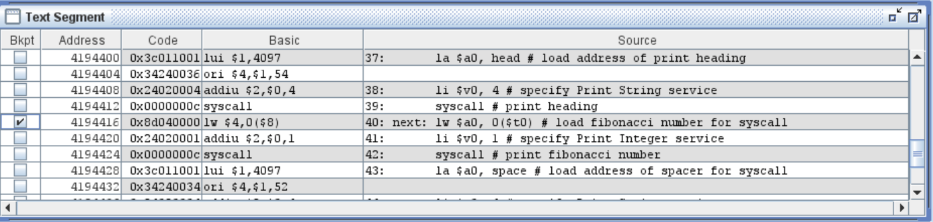

1. **Run the program at full speed and watch how it stops at the breakpoint.**

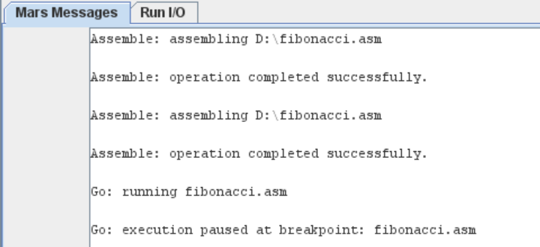

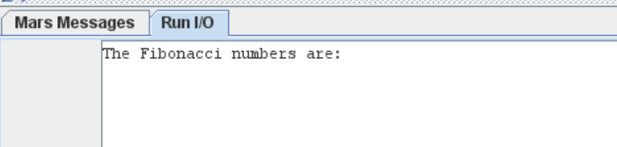

**i) Change the line:**

**space: .asciiz " " # space to insert between numbers**

**to:**

**space: .asciiz "\n" # space to insert between numbers**

**Run the program again. What do you notice?**

